**Origami Heart Step-by-Step Instructions**

**Material:** A flat 8.5” x 11” sheet of paper (printer paper).

**Step 1**: Fold the top Right-hand corner down so that it aligns with the edge of the paper. Unfold after completed.

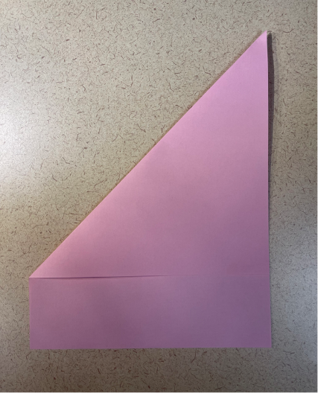

**Step 2**: Fold the top Left-hand corner down so that it aligns with the edge of the paper. Unfold after completed.

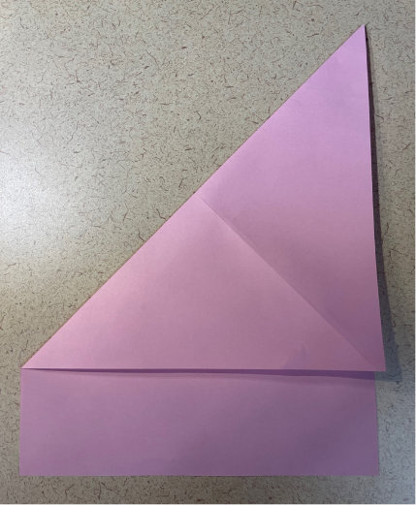

**Step 3**: Your paper should look like this:

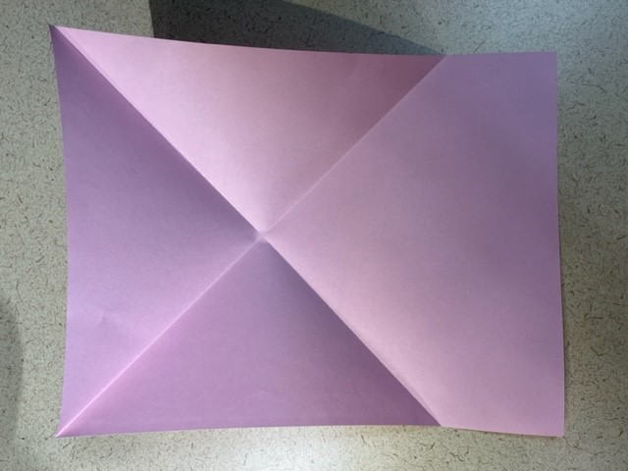

**Step 4**: Pinch the sides of the paper at the center point crease and bring the two edges (and your thumbs) inward towards each other and down towards the flat surface, creating a triangle. Press down and create strong creases.

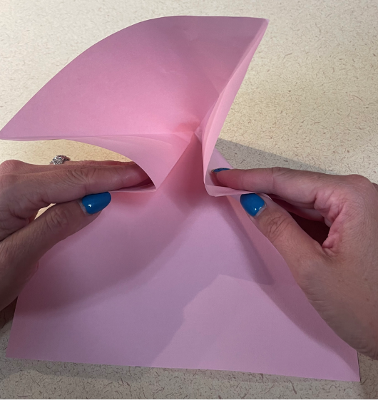 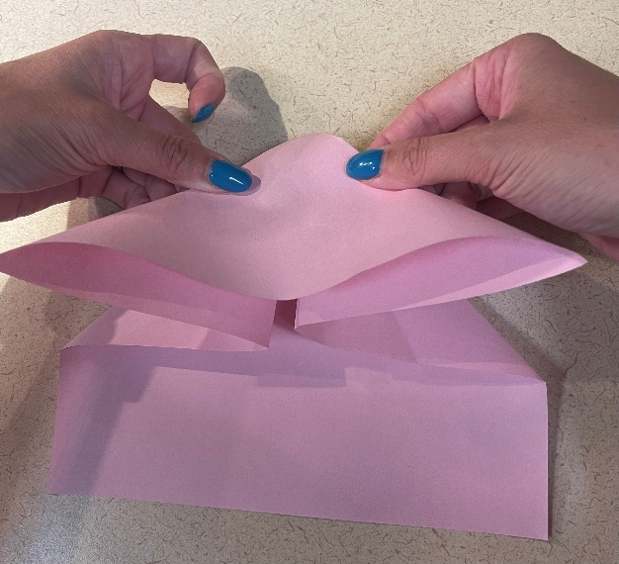

It should look like this:

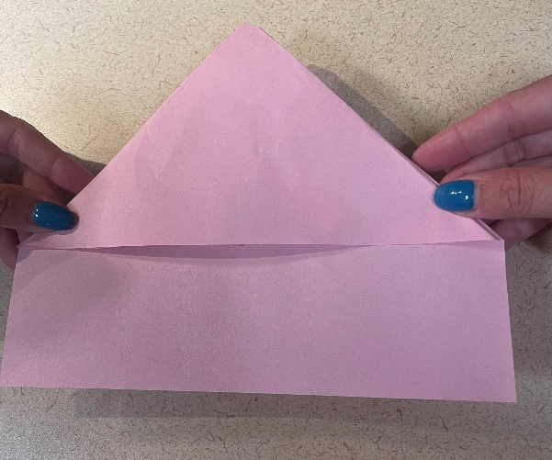

**Step 5**: Fold the Right-hand corner upward.

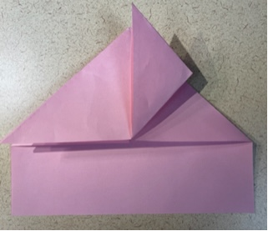

**Step 6**: Fold the Left-hand corner upward, completing the diamond.

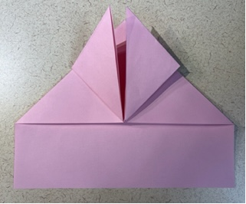

**Step 7**: Fold the Right-hand side of the paper, aligning the edge with the bottom point of the diamond.

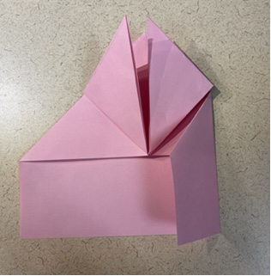

**Step 8**: Fold the Left-hand side of the paper, aligning the edge with the bottom of the diamond.

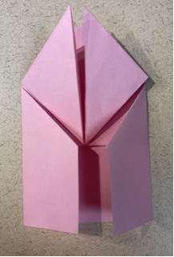

**Step 9**: Flip the paper over and it should look like this:

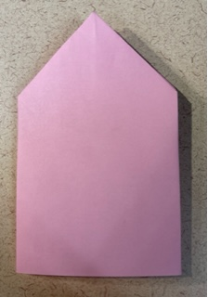

**Step 10**: Fold the bottom of the paper an inch and a half (1.5”).

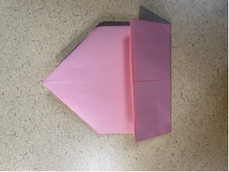

**Step 11**: Flip down the triangular section at the top (closest to you), making sure it folds all the way at the original crease.

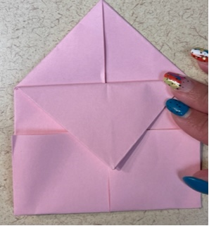

**Step 12**: Fold the bottom Right-hand corner up, creating a triangle.

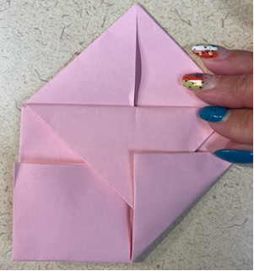

**Step 13**: Insert the triangle into the slot created by the larger triangle.

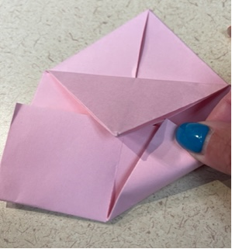 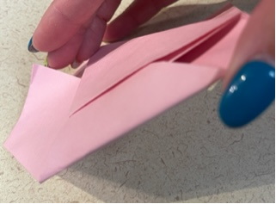

**Step 14**: Repeat step 12 and 13 with the bottom left hand corner, folding upward creating a triangle and inserting the triangle into the slot of the larger downward pointing triangle.

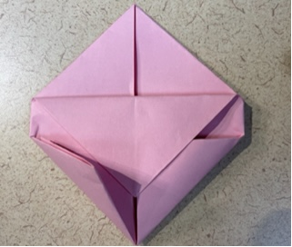 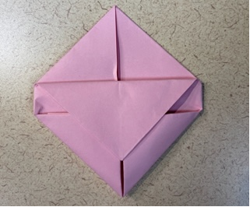 When they are both inserted, it will look like the 2nd photo.

**Step 15**: Fold the top Right top point down at an angle to form the top shape of a heart.

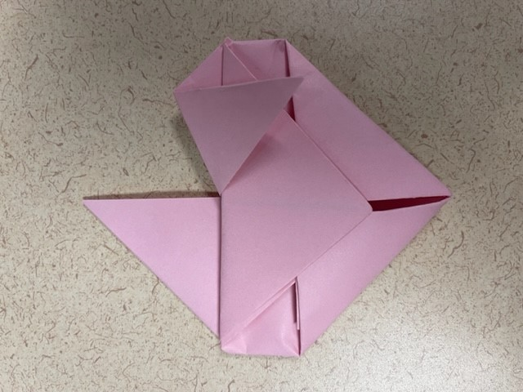

**Step 1****6**: Insert the remaining paper (the tail) inside the slot created by the larger downward triangle, to hold the top in place.

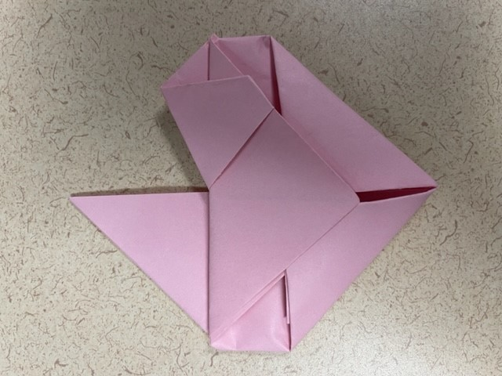

**Step 17**: Fold the top left point down at an angle to form the top shape of a heart. (Repeating previous steps to other side).

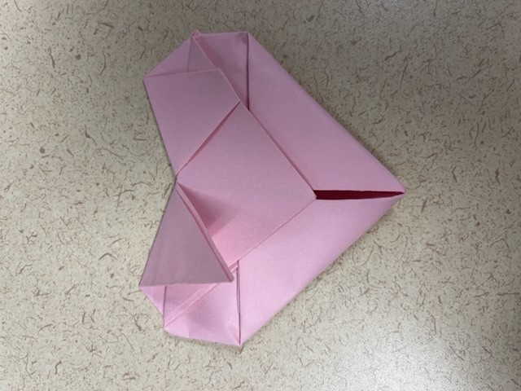

**Step 18**: Insert the remaining paper (the tail) inside the slot created by the larger triangle, to hold the top in place.

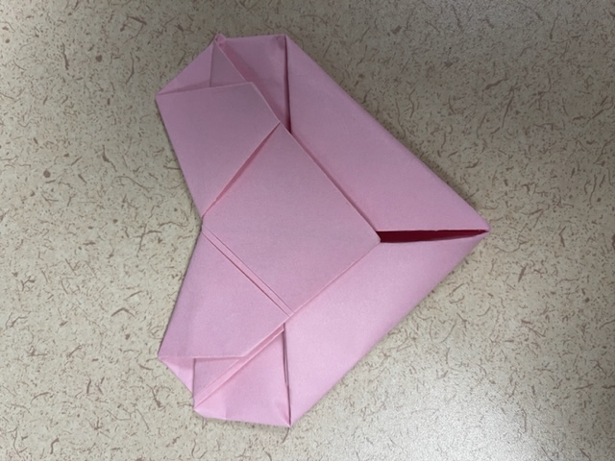

**Step 19**: TADA! You made an origami heart!!! Great job! 😊

